**Internet in South Korea**

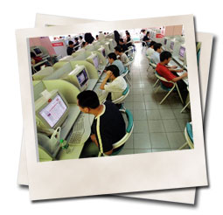Internet in Korea has one of the highest rates of usage in the world.

Due to strong government support, Korea has one of the highest rates of broadband connectivity, with most households being able to choose ISDN, ADSL, cable, or satellite internet for connectivity. All new apartments in Korea come hardwired with broadband. The average cost of a broadband connection with unlimited bandwidth and incredible up and download speeds (ranging from 10MB-30MB) is $28 USD per month, while an internet connection with unlimited access but slightly slower speeds is only $8 USD per month.

If your apartment doesn’t come with a computer, you will surely have internet access at your school. Outside of school, internet cafés are ubiquitous on the streets of Korea, and time is dirt cheap, most charge as little as a dollar per hour. These places are known as PC Bangs (computer rooms). You will usually see these rooms filled with teens chain smoking and playing on-line games such as Starcraft. A Korean teenager died after spending four days straight in a computer room without food or sleep.

**Should I buy a computer in Korea**

Brand name computers are not much cheaper in Korea than they are in the US and Canada. 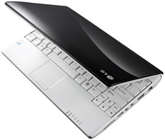  
  
I can't comment on the UK or SA or NZ but they are a good deal cheaper than in Australia. If you're looking for a REAL deal, inexpensive clones can be picked up quite cheaply in the electronics market near Yongsan in Seoul.

It is very important to keep in mind that if you buy a computer in [Korea](http://www.footprintsrecruiting.com/teaching-jobs-in-asia/teaching-jobs-in-korea) it is going to come with a Korean operating system, and unless you are fluent in Korean, you are pretty much stuck if anything goes wrong and error messages start popping up in Korean. When buying the computer you can specifically ask that the English version of Windows be loaded on it.

If you choose to bring a computer from home make sure it can handle the power supply. Older computers will need a converter while newer computers have built in power converters. Virtually all laptops, unless you have a very ancient one, can accept 110-240. Check the power cord - the box/rectangular thingy should have a bunch of numbers on it. Look at the volts.

**Getting Connected to the Internet in Korea**

Broadband companies offer fast Internet access to homes and businesses through leased lines, cable modems, xDSL, satellite, and others.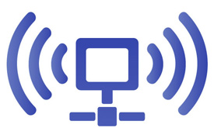  
  
Because of competition, prices can change quickly. Companies periodically offer special rates when adding a new service to a neighborhood.

Here are some companies to try:

* [Wibro](http://www.wibro.or.kr/new/overview01.jsp)
* [SK Broadband](http://www.skbroadband.com/)
* Olleh
* [Dreamline](http://www.dreamline.co.kr/main/main.php)